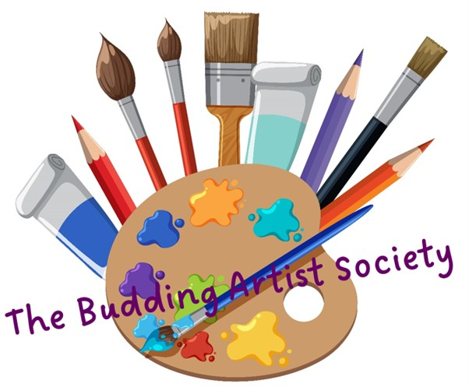

|  |  |  |  |  |  |
| --- | --- | --- | --- | --- | --- |
| **The Budding Artist Society**  **Booking Request Form** | | | | | |
| **To request a place on the workshops please complete this booking form and email it to rachael@artsandmindscentre.co.uk** | | | | | |
| Parent/Carer Name: | |  | | | |
| Parent/Carer Address: | |  | | | |
| Parent/Carer Email: | |  | | | |
| Parent Carer Phone Number: | |  | | | |
| Emergency Contact Name and Number: | |  | | | |
| Would you like to be added to The Budding Artist Society WhatsApp Group? (quick access to workshop updates and special offers) | | | | | Yes/No |
| Child 1 Name: |  | Child 2 Name: | |  | |
| Child 1 Age: |  | Child 2 Age: | |  | |
| Child 1 Allergies: |  | Child 2 Allergies: | |  | |
| **Easter Holiday Workshops** | | | | | |
| Workshop Selection (please remove the workshops you don’t want) | Mon 25th March: Picasso  Tue 26th March: Van Gogh  Wed 27th March: Kandinsky  Thurs 28th March: Riley  Tues 2nd April: Dali  Wed 3rd April: Matisse  Thurs 4th April: Lichtenstein  Fri 5th April: Klimt | Workshop Selection (please remove the workshops you don’t want) | | Mon 25th March: Picasso  Tue 26th March: Van Gogh  Wed 27th March: Kandinsky  Thurs 28th March: Riley  Tues 2nd April: Dali  Wed 3rd April: Matisse  Thurs 4th April: Lichtenstein  Fri 5th April: Klimt | |
| Child 3 Name: |  | Child 4 Name: | |  | |
| Child 3 Age: |  | Child 4 Age: | |  | |
| Child 3 Allergies: |  | Child 4 Allergies: | |  | |
| Workshop Selection (please remove the workshops you don’t want) | Mon 25th March: Picasso  Tue 26th March: Van Gogh  Wed 27th March: Kandinsky  Thurs 28th March: Riley  Tues 2nd April: Dali  Wed 3rd April: Matisse  Thurs 4th April: Lichtenstein  Fri 5th April: Klimt | Workshop Selection (please remove the workshops you don’t want) | | Mon 25th March: Picasso  Tue 26th March: Van Gogh  Wed 27th March: Kandinsky  Thurs 28th March: Riley  Tues 2nd April: Dali  Wed 3rd April: Matisse  Thurs 4th April: Lichtenstein  Fri 5th April: Klimt | |
| **Confirmation of a secured place on the workshop will be sent via email along with payment details. Each workshop costs £20 for each child which includes tuition, resources, materials and refreshments.** | | | | | |
| Address Arts and Minds Studio, The Stables, Weston Park, Weston Under Lizard TF11 8LE (Please meet at the covered entrance to the Granary at 9.30am, collection will be at midday at the same location) | | | Email: [rachael@artsandmindscentre.co.uk](mailto:rachael@artsandmindscentre.co.uk)  Website: artsandmindcentre.co.uk  Phone/Text: 07817365972 | | |
| **Taught by Local Artist and Teacher - Rachael Brown**  **Enhanced DBS, Designated Safeguarding Lead, Paediatric First Aid** | | | | | |
| **Thank you for your interest in The Budding Artist Society** | | | | | |